Ideation Phase
Define the Problem Statements

Date | 26 February 2026
Team ID | LTVIP2026TMIDS74388
Project Name | LAPTOP REQUEST CATALOG ITEM
Maximum Marks | 2 Marks

Customer Problem Statement :
Employees and IT teams face challenges when requesting laptops through the catalog system due to unclear specifications, lack of role-based recommendations, and inefficient approval processes. This results in delayed onboarding, mismatched devices, and increased administrative burden, ultimately hindering productivity and user satisfaction.
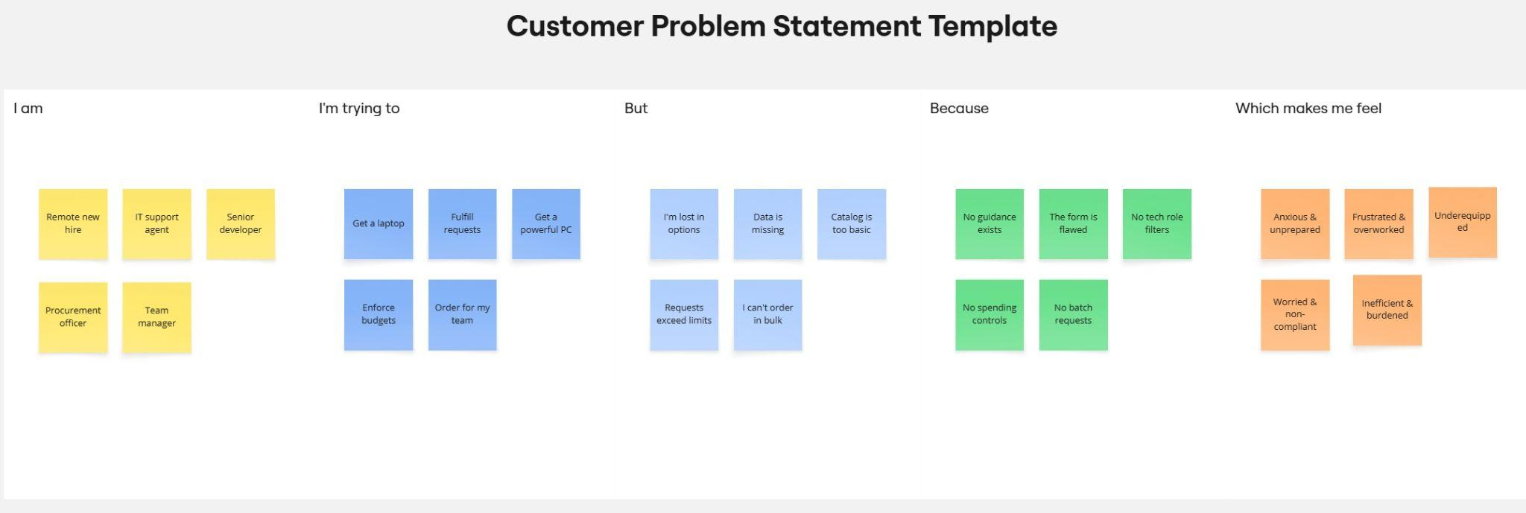

Problem Statement (PS) | I am (Customer) | I’m trying to | But | Because | Which makes me feel
PS-1 | Remote new hire | Get a laptop | I'm lost in options | No guidance exists | Anxious & unprepared
PS-2 | IT support agent | Fulfill requests | Data is missing | The form is flawed | Frustrated & overworked
PS-3 | Senior developer | Get a powerful PC | Catalog is too basic | No tech role filters | Underequipped
PS-4 | Procurement officer | Enforce budgets | Requests exceed limits | No spending controls | Worried & non-compliant
PS-5 | Team manager | Order for my team | I can't order in bulk | No batch requests | Inefficient & Burdened

